**EMPLOYEE ATTENDANCE BASED SALARY**



A Course Project Report

in partial fulfillment of the subject

**Object-Oriented Programming concepts through Java**

By

**G.Tharun Teja 20K45A0405**

**A.Vinay Kumar 20K45A0401**

Under the Guidance of

**Dr. K. Ravi Chaitanya**

Assistant Professor in CSE

**Submitted to**

**DEPARTMENT OF ELECTRONICS & COMMUNICATION ENGINEERING**

# S.R.ENGINEERING COLLEGE (A), ANANTHASAGAR, WARANGAL

# **(Affiliated to JNTUH, Accredited by NBA)**

**May, 2022.**



**DEPARTMENT OF ELECTRONICS & COMMUNICATION ENGINEERING**

**CERTIFICATE**

This is to certify that the Course Project Report entitled “**EMPLOYEE ATTENDANCE BASED SALARY**” is a record of bonafide work carried out by the student G.Tharun Teja and A.Vinay Kumar bearing Roll No: 20K45A0405,20K45A0401 during the academic year 2021-22 in partial fulfillment of the award of the degree of **Bachelor of Technology**in **ELECTRONICS & COMMUNICATION ENGINEERING** by the Jawaharlal Nehru Technological University, Hyderabad.

**Supervisor Head of the Department**

**ACKNOWLEDGEMENT**

We owe an enormous debt of gratitude toour project guide **Dr. K. Ravi Chaitanya, Assistant Professor in CSE** for guiding us from the beginning through the end of the Capstone project with their intellectual advice and insightful suggestions. We truly value their consistent feedback on our progress, which was always constructive, encouraging and ultimately drove us to the right direction.

We express our thanks to Head of the ECE Department **Dr. Sandip Bhattacharya, Associate Professor,** for his/her encouragement and support.

We wish to take this opportunity to express our sincere gratitude and deep sense of respect to our beloved Principal, **Dr. V. Mahesh,** for his continuous support and guidance to complete this project in the institute.

Finally, we express our thanks to all the teaching and non-teaching staff of the department for their suggestions and timely support.

**ABSTRACT**

Staff Attendance System is a simple windows based attendance system that was specifically developed for small and medium scale companies. This software helps to manage the workforce and attendance and calculates the salary for attending days in an easier way. This software application can manage the recordings, control and monitor the attendance. The significance of this application is to make sure that the staff members attendance management and calculation of salary for attend days. Currently, there is no proper system to monitor the staff attendance at some companies. Some companies still use the paper based system to store the records of the employees. With the implementation of this system, paper based systems will be eliminated. This research will help the Administrator to manage recordings, monitoring and tracking the attendance of the employees. It provides an accurate attendance every day and accurate salary calculation management for the employees in order to sign in and sign out their attendance. In this paper, the Employee Attendance Based Salary System was developed using java programming language.

**TABLE OF CONTENTS**

| **Sl. No.** | **Content** | **Page No.** |
| --- | --- | --- |
| 1 | Introduction | 06 |
| 2 | Literature survey | 06 |
| 3 | Design | 07 |
| 4 | Implementation | 08 |
| 5 | Source Code | 13 |
| 6 | Results | 25 |
| 7 | Conclusion | 26 |
| 8 | Future scope | 26 |
| 9 | Bibliography | 27 |

**1. INTRODUCTION**

Attendance is an important factor in maintaining the quality of an employee's performance in a company. With technological advances such as nowadays, the ease of attendance can also be carried out easily, the use of the old attendance system is also considered less effective in today's employees need efficiency in the absent process, as implemented by this program which has left the old system attendance , where the previous abscess system used the signature system, In this old system, the majority of employees worked not only in the office having difficulty meeting clients outside the office at any time, because they had to come to the office if they wanted to be absent. Therefore they replaced it with a new system, namely using an application called Employee attendance Based salary. With a modern employee attendance system like this, it can help companies make arrangements for existing human resources and the purpose of this research is to determine the feasibility of an attendance system using Employee attendance Based salary for the future. By using this online attendance system employees can perform attendance efficiently and effectively according to the needs of each employee. The final result of this online attendance system is best for employees for attendance and salary calculation.

**PROBLEM STATEMENT**

Attendance management is the main role in any where.but taking attendance manually is one of the big tasks nowadays.

* calculating the attendance for present days is very difficult.
* manually the calculation of the presented days will be wrong.

**2. LITERATURE SURVEY**

[1].In the article of Employee Attendance Monitoring System written by Ajay Singh.in that tells All organizations use attendance management to record their employees initial and final work timings. Some organizations also save comprehensive records of attendance issues like who calls in sick and who arrives late. Manual time and attendance management systems totally believe highly skilled persons but the matter being that humans aren't perfect. With manual systems, it's an excellent pressure on management to correct details of employees' work at all times. It is often easy to accidentally switch details and find yourself with a false entry of knowledge or in hand written briefings. This error won't find you only with false information but also create problems in the payroll system. Reporting and checking that data are often time taking and expensive. In addition to tracing when employees work, organizations also need to keep tabs on when employees are not working with Performance Management Software in India[1].

**3. DESIGN**

**3.1 REQUIREMENT SPECIFICATION(S/W & H/W)**

**Hardware Requirements**

* **System** : Pentium 4, Intel Core i3, i5, i7 and 2GHz Minimum
* **RAM** : 4GB or above
* **Hard Disk** : 10GB or above
* **Input**  : Keyboard and Mouse
* **Output** : Monitor or PC

**Software Requirements**

* **OS** : Windows 8 above Versions
* **Platform** : Eclipse or VS code or java 1.8 version.
* **Program Language** : Java

**Diagram:**

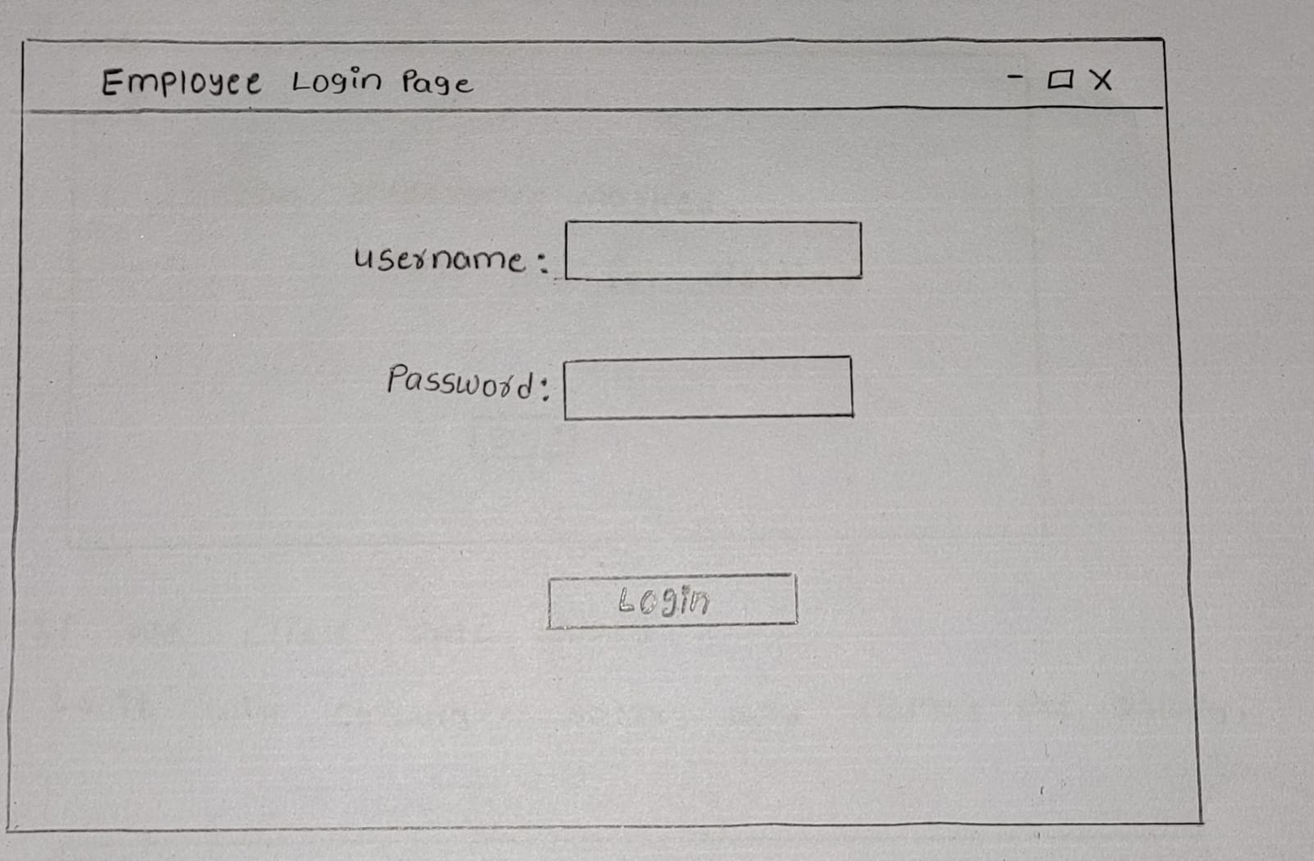

window1:login page

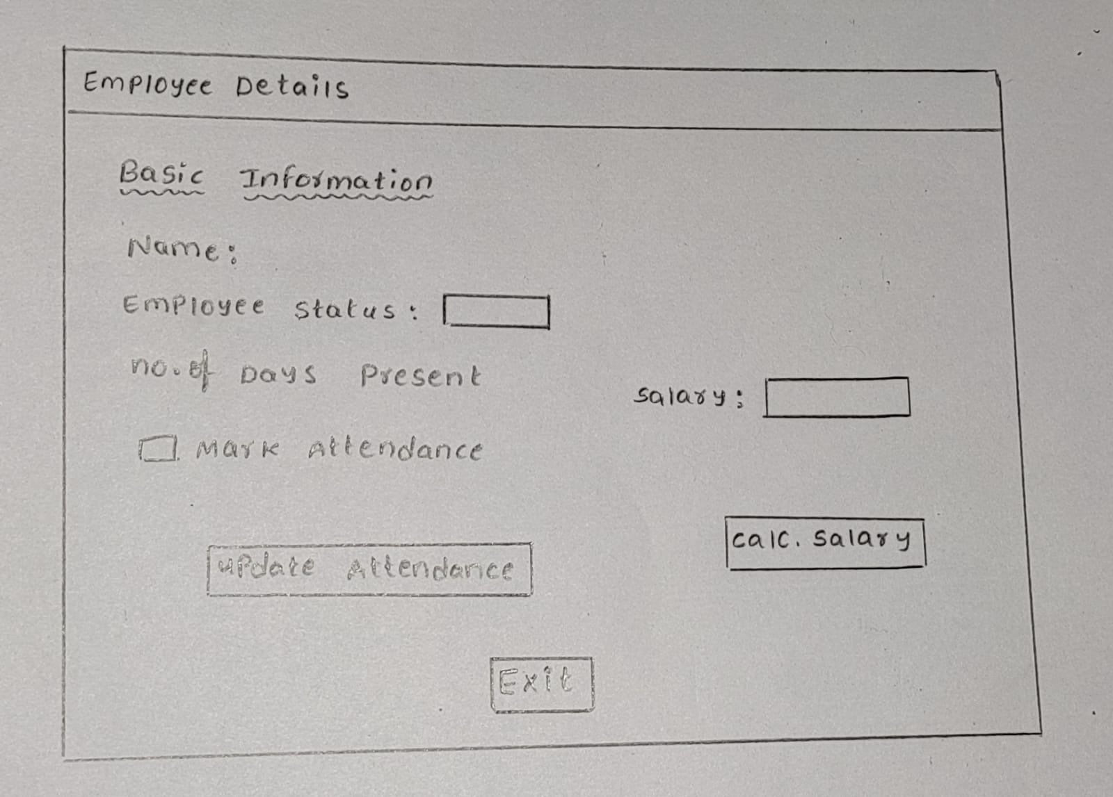

window2:Employee Details page

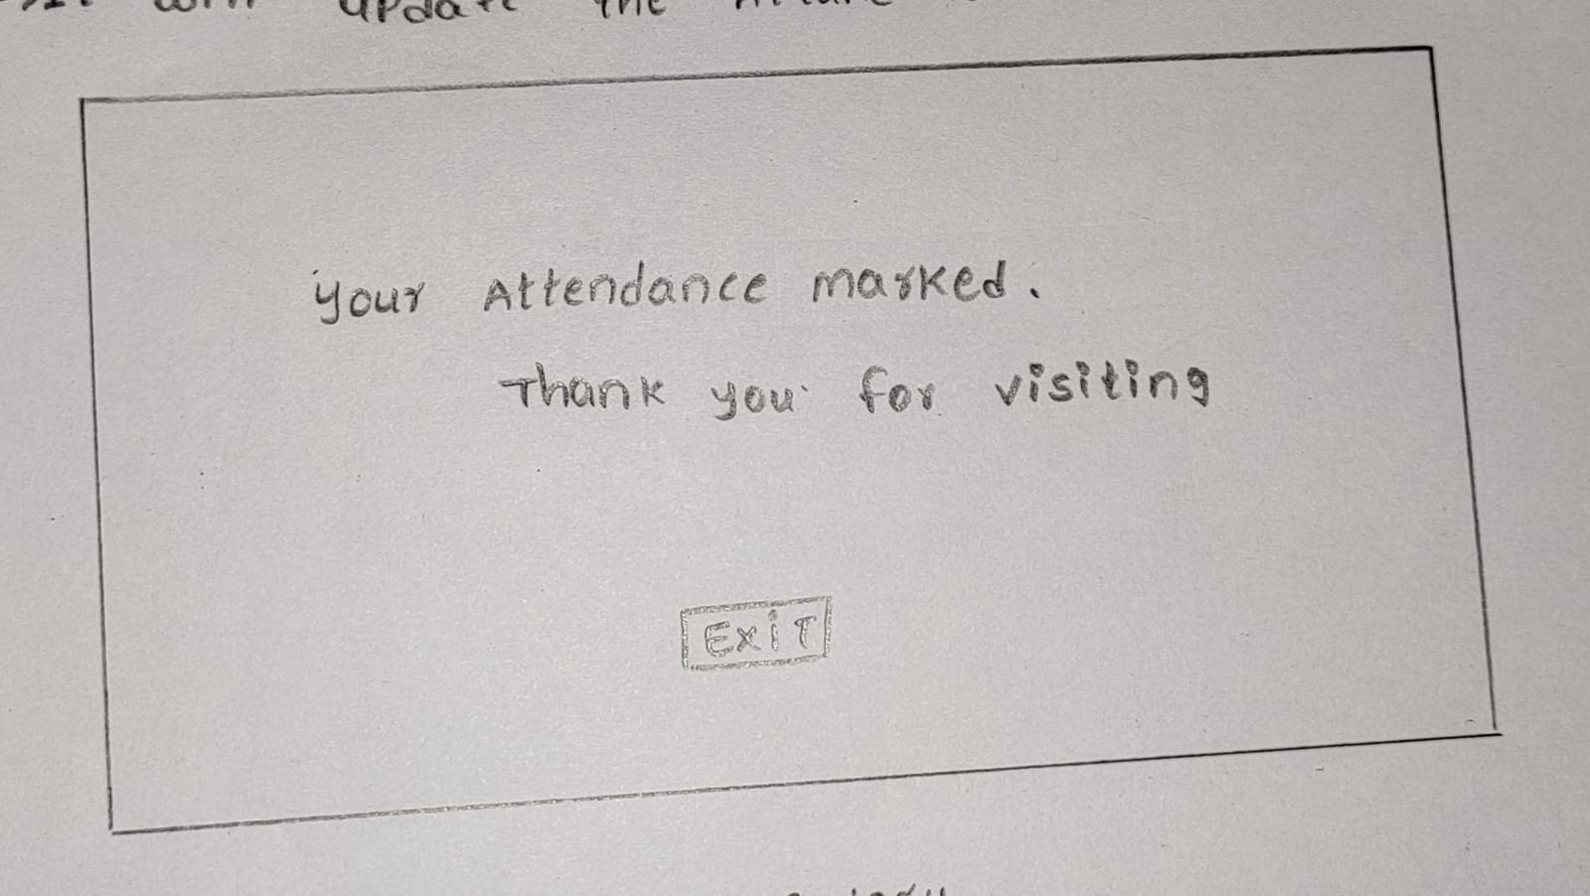

window3: Attendance marked page

**4. IMPLEMENTATION**

**JFrame:** The javax.swing.JFrame class is a type of container which inherits the java.awt.Frame class. JFrame works like the main window where components like labels, buttons, text fields are added to create a GUI.

Unlike Frame, JFrame has the option to hide or close the window with the help of setDefaultCloseOperation() method.

**JLabel:** The object of JLabel class is a component for placing text in a container. It is used to display a single line of read only text. The text can be changed by an application but a user cannot edit it directly. It inherits the JComponent class.

**JButton:** The JButton class is used to create a labeled button that has platform independent implementation. The application results in some action when the button is pushed. It inherits the AbstractButton class.

**setBounds( ):** Moves and resizes this component. The new location of the top-left corner is specified by x and y, and the new size is specified by width and height.

**setDefaultCloseOperation( ):** Sets the operation that will happen by default when the user initiates a "close" on this frame. You must specify one of the following choices:

* **DO_NOTHING_ON_CLOSE (defined in WindowConstants):** Don't do anything; require the program to handle the operation in the windowClosing method of a registered WindowListener object.
* **HIDE_ON_CLOSE (defined in WindowConstants):** Automatically hide the frame after invoking any registered WindowListener objects.
* DISPOSE_ON_CLOSE (defined in WindowConstants): Automatically hide and dispose the frame after invoking any registered WindowListener objects.
* **EXIT_ON_CLOSE (defined in WindowConstants):** Exit the application using the System exit method. Use this only in applications.

**setLayout( ):** Sets the LayoutManager. Overridden to conditionally forward the call to the contentPane.

**setVisible( ):** Shows or hides this Window depending on the value of parameter boolean b.

**addActionListener( ):** Adds an ActionListener to the button.

**ActionListener( ):** The listener interface for receiving action events. The class that is interested in processing an action event implements this interface, and the object created with that class is registered with a component, using the component's addActionListener method. When the action event occurs, that object's actionPerformed method is invoked.

**actionPerformed( ):** Invoked when an action occurs.

**ActionEvent:** A semantic event which indicates that a component-defined action occurred. This high-level event is generated by a component (such as a Button) when the component-specific action occurs (such as being pressed). The event is passed to every ActionListener object that registered to receive such events using the component's addActionListener method.

**add( ):** This method changes layout-related information, and therefore, invalidates the component hierarchy. If the container has already been displayed, the hierarchy must be validated thereafter in order to display the added component.

**getContentPane( ):** Returns the contentPane object for this frame.

**addItem( ):** Adds an item to the item list. This method works only if the JComboBox uses a mutable data model.

**setText( ):** Defines the single line of text this component will display. If the value of text is null or empty string, nothing is displayed.

**Overview of technology:**

**Window1:** In this window it consists of user name and password fields.

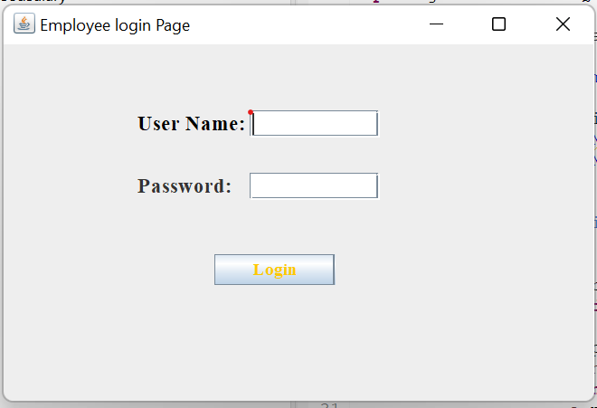 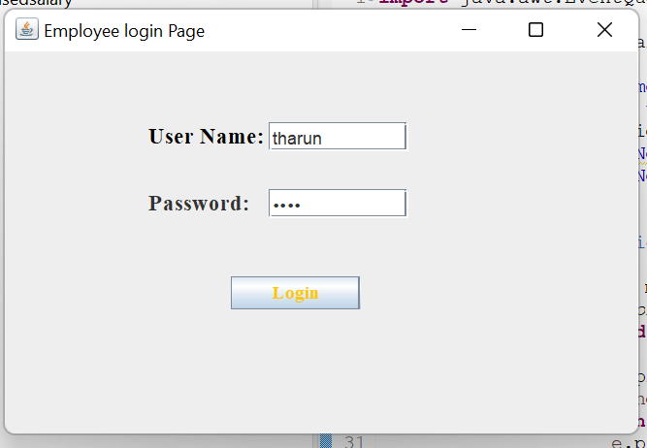

fig:login page

If we enter the wrong password it shows invalid password.

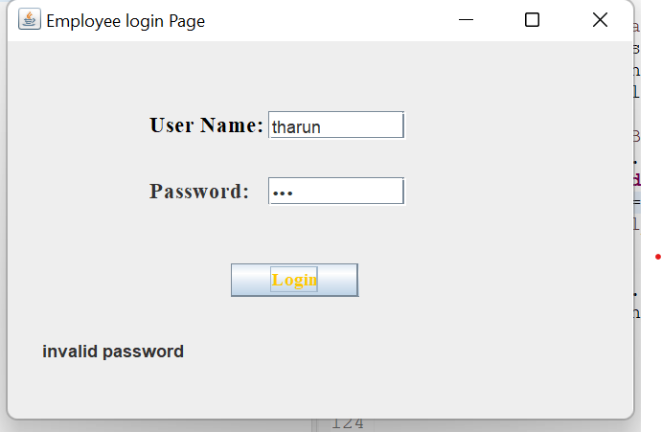

After entering username as tharun and password as 1234.It opens the employee details page.

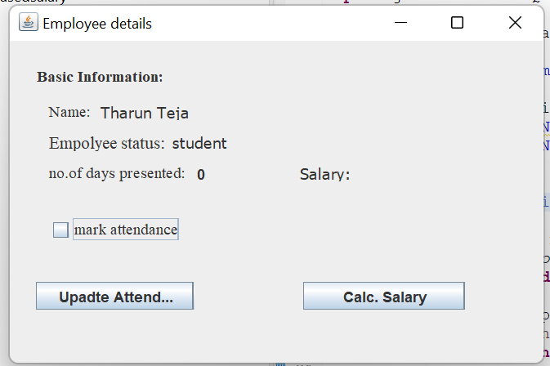

This is the employee details of employee 1 it consists of basic information.By clicking the update attendance we get marks successfully page.

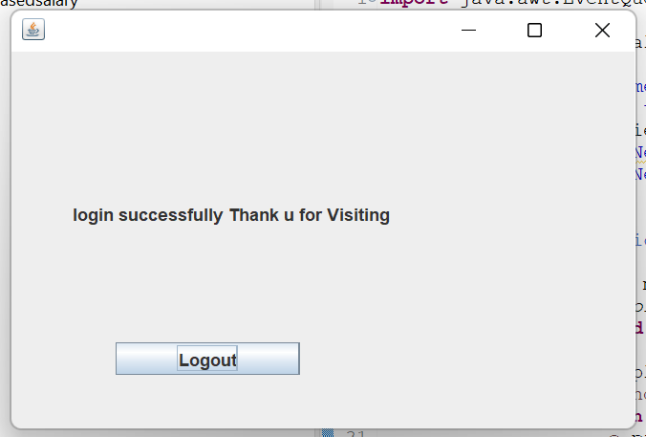

Attendance is marked and after one day by login the attendance will be updated to 1.and by clicking the salary button it calculates the salary for attended days the employee can check everyday salary.

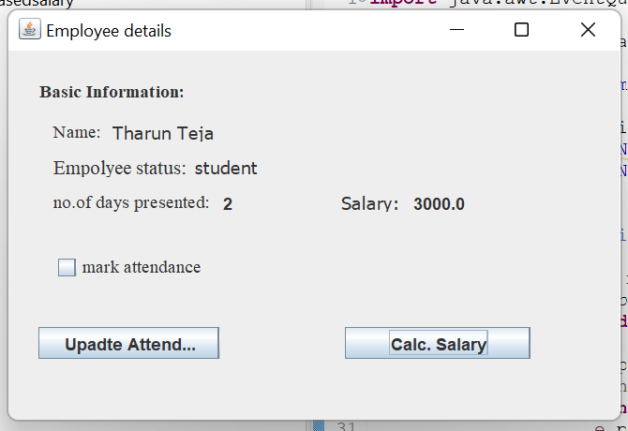

After clicking the salary button.it shows the salary for attended days.the presented days is 2 and per each day 1500(2*1500=3000).

**Another Employee2:**

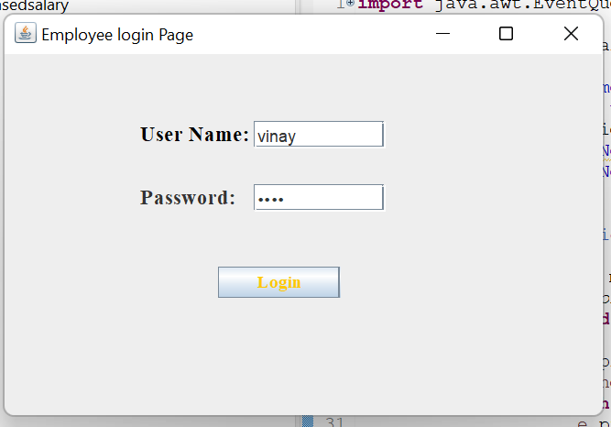

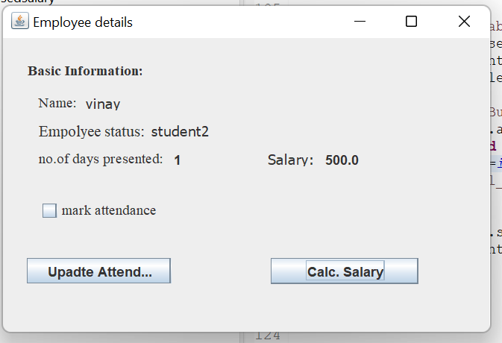

fig:details page of another employee



If we entered the wrong password it shows like this.

**5.Source Code:**

**SOURCE CODE FOR LOGIN PAGE:**

import java.awt.EventQueue;

import javax.swing.JFrame;

import javax.swing.JLabel;

import java.awt.Font;

import javax.swing.JTextField;

import javax.swing.JCheckBox;

import javax.swing.JButton;

import java.awt.event.ActionListener;

import java.awt.event.ActionEvent;

public class EmployeeDetails2 {

private JFrame frame;

static int i;

public double salary;

public String msg;

public static void main(String[] args) {

EventQueue.invokeLater(new Runnable() {

public void run() {

try {

EmployeeDetails2 window = new EmployeeDetails2();

window.frame.setVisible(true);

} catch (Exception e) {

e.printStackTrace();

}

}

});

}

public EmployeeDetails2() {

initialize();

}

private void initialize() {

frame = new JFrame("Employee details");

frame.setBounds(100, 100, 450, 300);

frame.setDefaultCloseOperation(JFrame.EXIT_ON_CLOSE);

frame.getContentPane().setLayout(null);

JLabel bi = new JLabel("Basic Information:");

bi.setFont(new Font("Times New Roman", Font.BOLD, 13));

bi.setBounds(22, 22, 119, 14);

frame.getContentPane().add(bi);

JLabel lblNewLabel_1 = new JLabel("Name:");

lblNewLabel_1.setFont(new Font("Times New Roman", Font.PLAIN, 13));

lblNewLabel_1.setBounds(32, 51, 49, 14);

frame.getContentPane().add(lblNewLabel_1);

JLabel lblNewLabel_2 = new JLabel("Empolyee status:");

lblNewLabel_2.setFont(new Font("Times New Roman", Font.PLAIN, 14));

lblNewLabel_2.setBounds(32, 76, 109, 14);

frame.getContentPane().add(lblNewLabel_2);

JLabel lblNewLabel_3 = new JLabel("no.of days presented:");

lblNewLabel_3.setFont(new Font("Times New Roman", Font.PLAIN, 13));

lblNewLabel_3.setBounds(32, 101, 132, 14);

frame.getContentPane().add(lblNewLabel_3);

JCheckBox chckbxNewCheckBox = new JCheckBox("mark attendance");

chckbxNewCheckBox.setFont(new Font("Times New Roman", Font.PLAIN, 13));

chckbxNewCheckBox.setBounds(32, 143, 132, 23);

frame.getContentPane().add(chckbxNewCheckBox);

JLabel lblNewLabel_7 = new JLabel("");

lblNewLabel_7.setBounds(153, 101, 49, 14);

frame.getContentPane().add(lblNewLabel_7);

lblNewLabel_7.setText(""+i);

JLabel lblNewLabel = new JLabel("");

lblNewLabel.setBounds(32, 172, 160, 14);

frame.getContentPane().add(lblNewLabel);

JButton btnNewButton = new JButton("Upadte Attendance");

btnNewButton.addActionListener(new ActionListener() {

public void actionPerformed(ActionEvent e) {

if(chckbxNewCheckBox.getModel().isSelected())

{

i++;

EndPage2 ed=new EndPage2();

frame.setVisible(false);

}

else {

msg="click mark attendance";

lblNewLabel.setText(""+msg);

}

}

});

btnNewButton.setBounds(22, 197, 129, 23);

frame.getContentPane().add(btnNewButton);

JLabel lblNewLabel_8 = new JLabel("");

lblNewLabel_8.setBounds(288, 101, 49, 14);

frame.getContentPane().add(lblNewLabel_8);

frame.setVisible(true);

JButton btnNewButton_1 = new JButton("Calc. Salary");

btnNewButton_1.addActionListener(new ActionListener() {

public void actionPerformed(ActionEvent e) {

salary=i*500;

lblNewLabel_8.setText(""+salary);

}

});

btnNewButton_1.setBounds(240, 197, 132, 23);

frame.getContentPane().add(btnNewButton_1);

if(i>=30) {

i=0;

}

JLabel lblNewLabel_4 = new JLabel("Salary:");

lblNewLabel_4.setFont(new Font("Tahoma", Font.PLAIN, 13));

lblNewLabel_4.setBounds(237, 101, 49, 14);

frame.getContentPane().add(lblNewLabel_4);

JLabel lblNewLabel_5 = new JLabel("vinay");

lblNewLabel_5.setFont(new Font("Tahoma", Font.PLAIN, 13));

lblNewLabel_5.setBounds(74, 51, 90, 14);

frame.getContentPane().add(lblNewLabel_5);

JLabel lblNewLabel_6 = new JLabel("student2");

lblNewLabel_6.setFont(new Font("Tahoma", Font.PLAIN, 13));

lblNewLabel_6.setBounds(133, 76, 59, 14);

frame.getContentPane().add(lblNewLabel_6);

}

private void textField(int i) {

// TODO Auto-generated method stub

}

}

**SOURCE CODE FOR EMPLOYEE DETAILS PAGE:**

**EMPLOYEE 1 CODE :**

import java.awt.EventQueue;

import javax.swing.JFrame;

import javax.swing.JLabel;

import java.awt.Font;

import javax.swing.JTextField;

import javax.swing.JCheckBox;

import javax.naming.InvalidNameException;

import javax.swing.JButton;

import java.awt.event.ActionListener;

import java.awt.event.ActionEvent;

public class EmployeeDetails1 {

private JFrame frame;

static int i;

public int month=30;

public double salary;

public String msg;

public static void main(String[] args) {

EventQueue.invokeLater(new Runnable() {

public void run() {

try {

EmployeeDetails1 window = new EmployeeDetails1();

window.frame.setVisible(true);

} catch (Exception e) {

e.printStackTrace();

}

}

});

}

public EmployeeDetails1() {

initialize();

}

private void initialize() {

frame = new JFrame("Employee details");

frame.setBounds(100, 100, 450, 300);

frame.setDefaultCloseOperation(JFrame.EXIT_ON_CLOSE);

frame.getContentPane().setLayout(null);

JLabel bi = new JLabel("Basic Information:");

bi.setFont(new Font("Times New Roman", Font.BOLD, 13));

bi.setBounds(22, 22, 119, 14);

frame.getContentPane().add(bi);

JLabel lblNewLabel_1 = new JLabel("Name:");

lblNewLabel_1.setFont(new Font("Times New Roman", Font.PLAIN, 13));

lblNewLabel_1.setBounds(32, 51, 49, 14);

frame.getContentPane().add(lblNewLabel_1);

JLabel lblNewLabel_2 = new JLabel("Empolyee status:");

lblNewLabel_2.setFont(new Font("Times New Roman", Font.PLAIN, 14));

lblNewLabel_2.setBounds(32, 76, 109, 14);

frame.getContentPane().add(lblNewLabel_2);

JLabel lblNewLabel_3 = new JLabel("no.of days presented:");

lblNewLabel_3.setFont(new Font("Times New Roman", Font.PLAIN, 13));

lblNewLabel_3.setBounds(32, 101, 132, 14);

frame.getContentPane().add(lblNewLabel_3);

JCheckBox cb = new JCheckBox("mark attendance");

cb.setFont(new Font("Times New Roman", Font.PLAIN, 13));

cb.setBounds(32, 143, 132, 23);

frame.getContentPane().add(cb);

JLabel lblNewLabel_7 = new JLabel("");

lblNewLabel_7.setBounds(153, 101, 49, 14);

frame.getContentPane().add(lblNewLabel_7);

lblNewLabel_7.setText(""+i);

JLabel lblNewLabel = new JLabel("");

lblNewLabel.setBounds(32, 172, 160, 14);

frame.getContentPane().add(lblNewLabel);

JButton btnNewButton = new JButton("Upadte Attendance");

btnNewButton.addActionListener(new ActionListener() {

public void actionPerformed(ActionEvent e) { if(cb.getModel().isSelected())

{

i++;

EndPage1 ed=new EndPage1();

frame.setVisible(false);

}

else {

msg="click mark attendance";

lblNewLabel.setText(""+msg);

}

}

});

btnNewButton.setBounds(22, 197, 129, 23);

frame.getContentPane().add(btnNewButton);

if(i>=30) {

i=0;

}

JLabel lblNewLabel_8 = new JLabel("");

lblNewLabel_8.setBounds(288, 101, 49, 14);

frame.getContentPane().add(lblNewLabel_8);

JButton btnNewButton_1 = new JButton("Calc. Salary");

btnNewButton_1.addActionListener(new ActionListener() {

public void actionPerformed(ActionEvent e) {

salary=i*1500;

lblNewLabel_8.setText(""+salary);

}

});

btnNewButton_1.setBounds(240, 197, 132, 23);

frame.getContentPane().add(btnNewButton_1);

JLabel lblNewLabel_4 = new JLabel("Salary:");

lblNewLabel_4.setFont(new Font("Tahoma", Font.PLAIN, 13));

lblNewLabel_4.setBounds(237, 101, 49, 14);

frame.getContentPane().add(lblNewLabel_4);

JLabel lblNewLabel_5 = new JLabel("Tharun Teja");

lblNewLabel_5.setFont(new Font("Tahoma", Font.PLAIN, 13));

lblNewLabel_5.setBounds(74, 51, 90, 14);

frame.getContentPane().add(lblNewLabel_5);

JLabel lblNewLabel_6 = new JLabel("student");

lblNewLabel_6.setFont(new Font("Tahoma", Font.PLAIN, 13));

lblNewLabel_6.setBounds(133, 76, 59, 14);

frame.getContentPane().add(lblNewLabel_6);

frame.setVisible(true);

}

private void textField(int i) {

// TODO Auto-generated method stub

}

}

**SOURCE CODE FOR EMPLOYEE DETAILS PAGE:**

**EMPLOYEE 2 CODE :**

import java.awt.EventQueue;

import javax.swing.JFrame;

import javax.swing.JLabel;

import java.awt.Font;

import javax.swing.JTextField;

import javax.swing.JCheckBox;

import javax.swing.JButton;

import java.awt.event.ActionListener;

import java.awt.event.ActionEvent;

public class EmployeeDetails2 {

private JFrame frame;

static int i;

public double salary;

public String msg;

public static void main(String[] args) {

EventQueue.invokeLater(new Runnable() {

public void run() {

try {

EmployeeDetails2 window = new EmployeeDetails2();

window.frame.setVisible(true);

} catch (Exception e) {

e.printStackTrace();

}

}

});

}

public EmployeeDetails2() {

initialize();

}

private void initialize() {

frame = new JFrame("Employee details");

frame.setBounds(100, 100, 450, 300);

frame.setDefaultCloseOperation(JFrame.EXIT_ON_CLOSE);

frame.getContentPane().setLayout(null);

JLabel bi = new JLabel("Basic Information:");

bi.setFont(new Font("Times New Roman", Font.BOLD, 13));

bi.setBounds(22, 22, 119, 14);

frame.getContentPane().add(bi);

JLabel lblNewLabel_1 = new JLabel("Name:");

lblNewLabel_1.setFont(new Font("Times New Roman", Font.PLAIN, 13));

lblNewLabel_1.setBounds(32, 51, 49, 14);

frame.getContentPane().add(lblNewLabel_1);

JLabel lblNewLabel_2 = new JLabel("Empolyee status:");

lblNewLabel_2.setFont(new Font("Times New Roman", Font.PLAIN, 14));

lblNewLabel_2.setBounds(32, 76, 109, 14);

frame.getContentPane().add(lblNewLabel_2);

JLabel lblNewLabel_3 = new JLabel("no.of days presented:");

lblNewLabel_3.setFont(new Font("Times New Roman", Font.PLAIN, 13));

lblNewLabel_3.setBounds(32, 101, 132, 14);

frame.getContentPane().add(lblNewLabel_3);

JCheckBox chckbxNewCheckBox = new JCheckBox("mark attendance");

chckbxNewCheckBox.setFont(new Font("Times New Roman", Font.PLAIN, 13));

chckbxNewCheckBox.setBounds(32, 143, 132, 23);

frame.getContentPane().add(chckbxNewCheckBox);

JLabel lblNewLabel_7 = new JLabel("");

lblNewLabel_7.setBounds(153, 101, 49, 14);

frame.getContentPane().add(lblNewLabel_7);

lblNewLabel_7.setText(""+i);

JLabel lblNewLabel = new JLabel("");

lblNewLabel.setBounds(32, 172, 160, 14);

frame.getContentPane().add(lblNewLabel);

JButton btnNewButton = new JButton("Upadte Attendance");

btnNewButton.addActionListener(new ActionListener() {

public void actionPerformed(ActionEvent e) {

if(chckbxNewCheckBox.getModel().isSelected())

{

i++;

EndPage1 ed=new EndPage1();

frame.setVisible(false);

}

else {

msg="click mark attendance";

lblNewLabel.setText(""+msg);

}

}

});

btnNewButton.setBounds(22, 197, 129, 23);

frame.getContentPane().add(btnNewButton);

JLabel lblNewLabel_8 = new JLabel("");

lblNewLabel_8.setBounds(288, 101, 49, 14);

frame.getContentPane().add(lblNewLabel_8);

frame.setVisible(true);

JButton btnNewButton_1 = new JButton("Calc. Salary");

btnNewButton_1.addActionListener(new ActionListener() {

public void actionPerformed(ActionEvent e) {

salary=i*500;

lblNewLabel_8.setText(""+salary);

}

});

btnNewButton_1.setBounds(240, 197, 132, 23);

frame.getContentPane().add(btnNewButton_1);

if(i>=30) {

i=0;

}

JLabel lblNewLabel_4 = new JLabel("Salary:");

lblNewLabel_4.setFont(new Font("Tahoma", Font.PLAIN, 13));

lblNewLabel_4.setBounds(237, 101, 49, 14);

frame.getContentPane().add(lblNewLabel_4);

JLabel lblNewLabel_5 = new JLabel("vinay");

lblNewLabel_5.setFont(new Font("Tahoma", Font.PLAIN, 13));

lblNewLabel_5.setBounds(74, 51, 90, 14);

frame.getContentPane().add(lblNewLabel_5);

JLabel lblNewLabel_6 = new JLabel("student2");

lblNewLabel_6.setFont(new Font("Tahoma", Font.PLAIN, 13));

lblNewLabel_6.setBounds(133, 76, 59, 14);

frame.getContentPane().add(lblNewLabel_6);

}

private void textField(int i) {

// TODO Auto-generated method stub

}

}

**SOURCE CODE FOR END PAGE:**

import java.awt.EventQueue;

import java.awt.event.ActionEvent;

import java.awt.event.ActionListener;

import javax.swing.JFrame;

import javax.swing.JLabel;

import javax.swing.JButton;

public class EndPage1 {

private JFrame frame;

public static void main(String[] args) {

EventQueue.invokeLater(new Runnable() {

public void run() {

try {

EndPage1 window = new EndPage1();

window.frame.setVisible(true);

} catch (Exception e) {

e.printStackTrace();

}

}

});

}

public EndPage1() {

initialize();

}

private void initialize() {

frame = new JFrame();

frame.setBounds(100, 100, 450, 300);

frame.setDefaultCloseOperation(JFrame.EXIT_ON_CLOSE);

frame.getContentPane().setLayout(null);

JLabel output = new JLabel("New label");

output.setBounds(43, 75, 335, 76);

frame.getContentPane().add(output);

String name="login successfully Thank u for Visiting";

output.setText(name);

JButton btnNewButton = new JButton("Logout");

btnNewButton.addActionListener(new ActionListener() {

public void actionPerformed(ActionEvent e) {

Employeesalary ec=new Employeesalary();

frame.setVisible(false);

}

});

btnNewButton.setBounds(73, 203, 129, 23);

frame.getContentPane().add(btnNewButton);

frame.setVisible(true);

}

}

**6. RESULTS:**

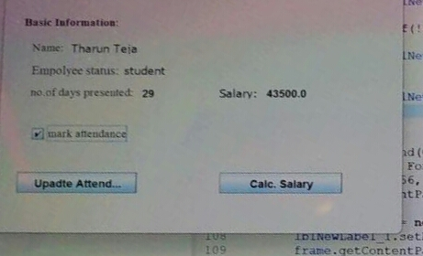

**fig : output of the application.**

**7. CONCLUSION**

Our project employee attendance based salary is used for monitoring attendance and calculating the salary for each day and every day we use it to check the attendance and how much we get.

**8. FUTURE SCOPE**

This application can be further improved by adding more futures like biometric commending according to the user needs, adding pictures of the employee and over all making it more user friendly.

**9. BIBLIOGRAPHY**

[1].Solihin, Ahmad, MySQL 5 From Beginner to Advanced, Achmatim. net. Jakarta. <https://www.firebase.com> features.html, accessed September 26, 2015.[1].

[2]Anjum R, & Kamble V, 2016, “RFID Student Navigation System,” Int J Sci Res Sci Technol. International Journal of Science 2(6) pp. 463-467.

[3] Nainan S Parekh R & Shah T, 2013, “RFID technology-based attendance management system,” International Journal of Science 13, 11-17.

[4] Mishra Y Marwah, G. K, & Verma S, 2015, “Arduino Based Smart RFID Security and Attendance System with Audio Acknowledgement,” International Journal of Engineering Research and Technology 4(1) pp. 1-5.

[5] Maramis G. D. P., and Rompas P. T. D., 2018, “Radio Frequency Identification (RFID) Based Employee Attendance Management System,” In IOP Conference Series: Materials Science and Engineering IOP Publishing. International Journal of Science, 306(1) p. 012045.